ESP 8266 Board install in New IDE 2.0

[HOME](https://randomnerdtutorials.com/) [ESP32](https://randomnerdtutorials.com/projects-esp32/) [ESP8266](https://randomnerdtutorials.com/projects-esp8266/) [ESP32-CAM](https://randomnerdtutorials.com/projects-esp32-cam/) [RASPBERRY PI](https://randomnerdtutorials.com/projects-raspberry-pi/) [MICROPYTHON](https://randomnerdtutorials.com/projects-esp32-esp8266-micropython/) [RPi PICO](https://randomnerdtutorials.com/projects-raspberry-pi-pico/) [ARDUINO](https://randomnerdtutorials.com/projects-arduino/) [REVIEWS](https://makeradvisor.com/)

**Installing ESP8266 NodeMCU Board in Arduino IDE 2 (Windows, Mac OS X, Linux)**

There is a new Arduino IDE—Arduino IDE 2. In this tutorial, you’ll learn how to install the ESP8266 boards in Arduino IDE 2.X and upload code to the board. This tutorial is compatible with Windows, Mac OS X, and Linux operating systems.

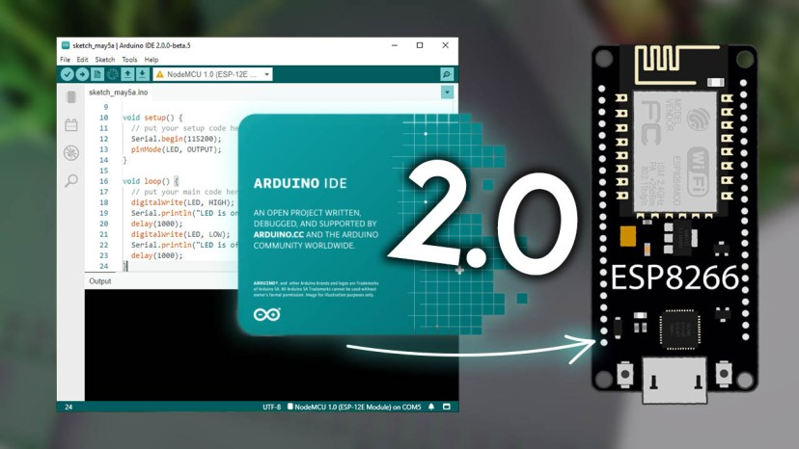

According to the Arduino website: “*The Arduino IDE 2.0 is an improvement of the classic IDE, with increased performance, improved user interface and many new features, such as autocompletion, a built-in debugger and syncing sketches with Arduino Cloud*“.

If you want to install the ESP8266 boards on the “classic” Arduino IDE, follow the next tutorial instead:

* [Installing the ESP8266 Board in Arduino IDE (Windows, Mac OS X, Linux)](https://randomnerdtutorials.com/how-to-install-esp8266-board-arduino-ide/)

If you prefer programming the ESP8266 using VS Code + PlatformIO, go to the following tutorial:

* [Getting Started with VS Code and PlatformIO IDE for ESP32 and ESP8266 (Windows, Mac OS X, Linux Ubuntu)](https://randomnerdtutorials.com/vs-code-platformio-ide-esp32-esp8266-arduino/)

You might also like reading the ESP32 Guide: [Installing ESP32 Board in Arduino IDE 2.0 (Windows, Mac OS X, Linux)](https://randomnerdtutorials.com/installing-esp32-arduino-ide-2-0/)

**Prerequisites: Arduino IDE 2 Installed**

Before proceeding make sure you have [Arduino IDE 2](https://www.arduino.cc/en/Tutorial/getting-started-with-ide-v2) installed on your computer.

Go to the [Arduino website and download the version](https://www.arduino.cc/en/software#experimental-software) for your operating system.

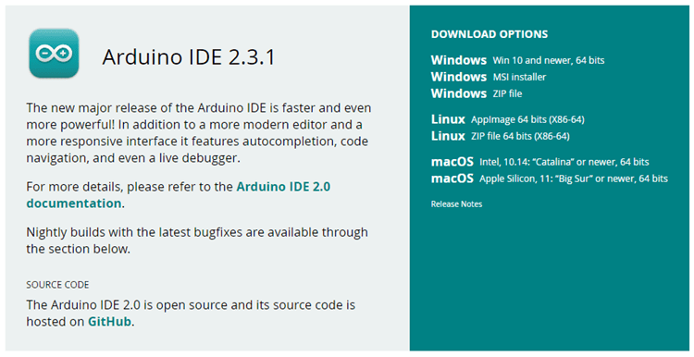

* **Windows**: run the file downloaded and follow the instructions in the installation guide.
* **Mac OS X**: copy the downloaded file into your application folder.
* **Linux**: extract the downloaded file, and open the arduino-ide file that will launch the IDE.

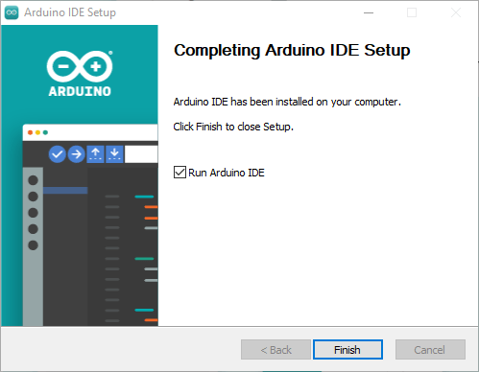

If you have doubts, you can go to the [Arduino Installation Guide](https://www.arduino.cc/en/Tutorial/getting-started-with-ide-v2/ide-v2-downloading-and-installing).

**Do you need an ESP8266 board?**You can [buy it here](https://makeradvisor.com/tools/esp8266-esp-12e-nodemcu-wi-fi-development-board/).

Recommended reading: [Best ESP8266 Boards Comparison](https://makeradvisor.com/best-esp8266-wi-fi-development-board/)

**Install ESP8266 NodeMCU Add-on in Arduino IDE 2**

To install the ESP8266 board in your Arduino IDE 2, follow these next instructions:

**1.**In the Arduino IDE 2, go to **File**> **Preferences**.

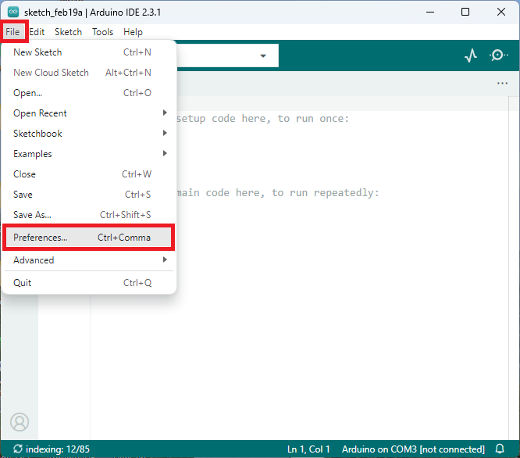

**2.** Copy and paste the following line to the **Additional Boards Manager** URLs field.

http://arduino.esp8266.com/stable/package_esp8266com_index.json

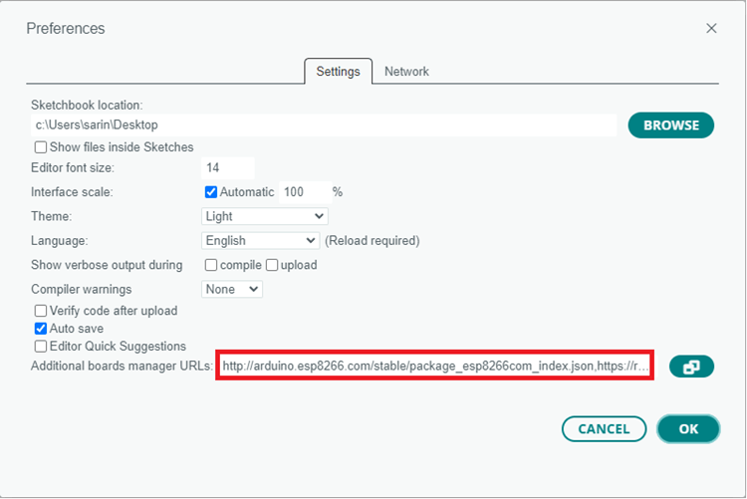

**Note:** if you already have the ESP32 boards URL, you can separate the URLs with a comma, as follows:

http://arduino.esp8266.com/stable/package_esp8266com_index.json, https://raw.githubusercontent.com/espressif/arduino-esp32/gh-pages/package_esp32_index.json

3. Open the Boards Manager. You can go to **Tools**> **Board**> **Boards Manager…** or you can simply click the **Boards Manager**icon in the left-side corner.

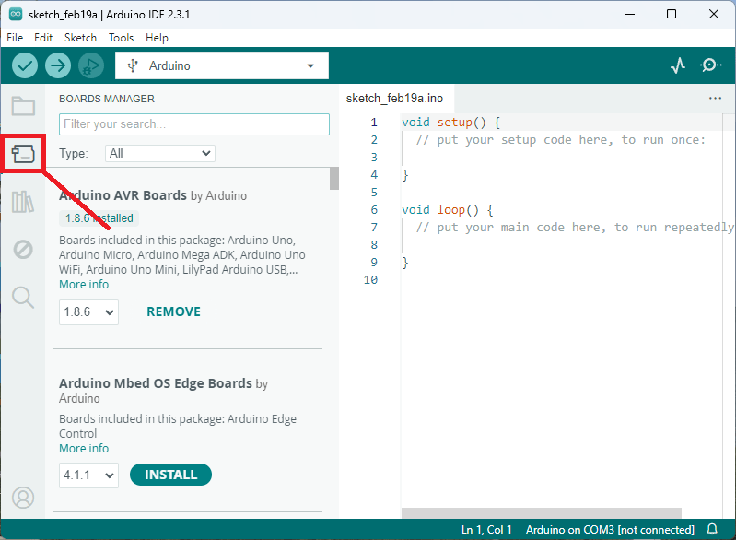

4. Search for **ESP8266**and press the install button for **esp8266 by ESP8266 Community**.

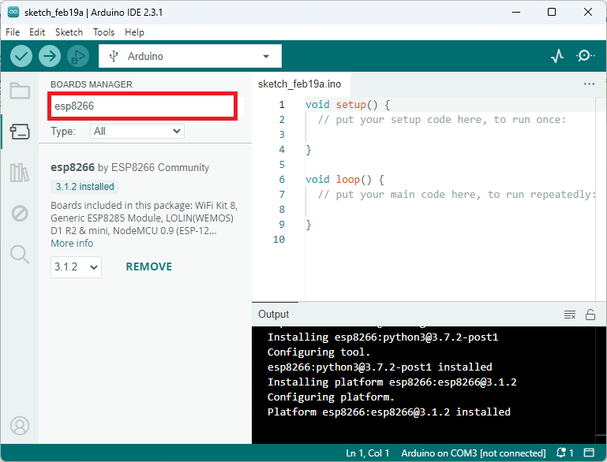

That’s it. It should be installed after a few seconds.

**Testing the Installation**

To test the ESP8266 add-on installation, we’ll upload a simple code that blinks the on-board LED (GPIO 2).

Copy the following code to your Arduino IDE:

/*********

Rui Santos

Complete project details at https://RandomNerdTutorials.com/vs-code-platformio-ide-esp32-esp8266-arduino/

*********/

#include <Arduino.h>

#define LED 2

void setup() {

// put your setup code here, to run once:

Serial.begin(115200);

pinMode(LED, OUTPUT);

}

void loop() {

// put your main code here, to run repeatedly:

digitalWrite(LED, HIGH);

Serial.println("LED is on");

delay(1000);

digitalWrite(LED, LOW);

Serial.println("LED is off");

delay(1000);

}

[View raw code](https://github.com/RuiSantosdotme/Random-Nerd-Tutorials/raw/master/Projects/ESP/ESP_Blink_VS_Code.ino)

**Uploading the Sketch**

Select your board before uploading the code. On the top drop-down menu, click on “**Select other board and port…**“

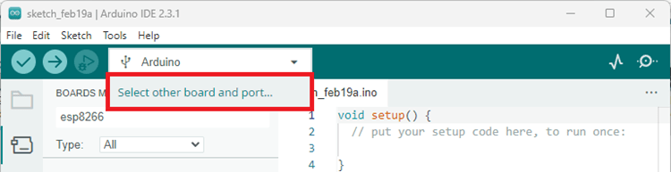

A new window, as shown below, will open. Search for your ESP8266 board model

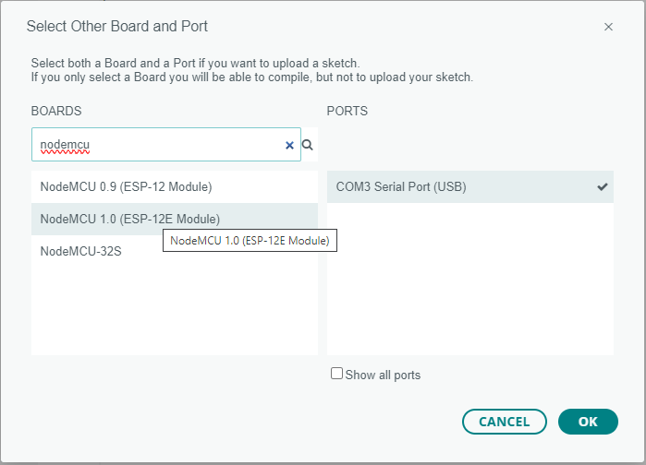

Select the ESP8266 board model you’re using, and the COM port. In our example, we’re using the NodeMCU 1.0 board. Click **OK** when you’re done.

Now, you just need to click on the **Upload**button.

Arduino IDE 2 Upload Button

After a few seconds, the upload should be complete.

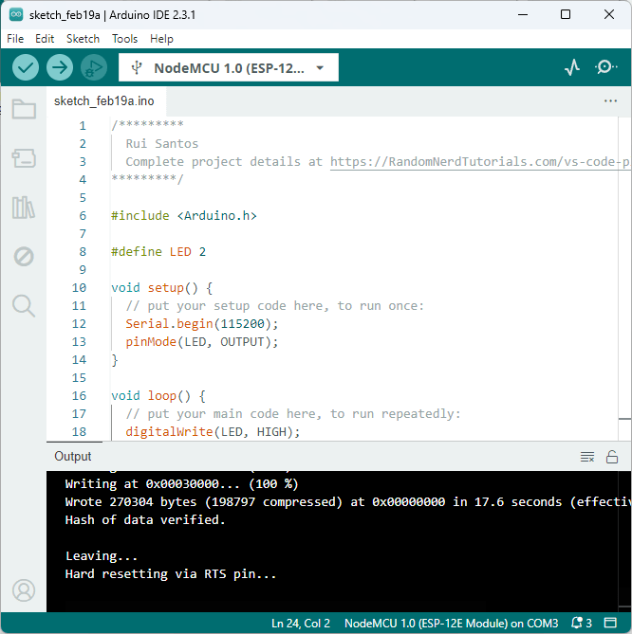

The ESP8266 on-board LED should be blinking every second.

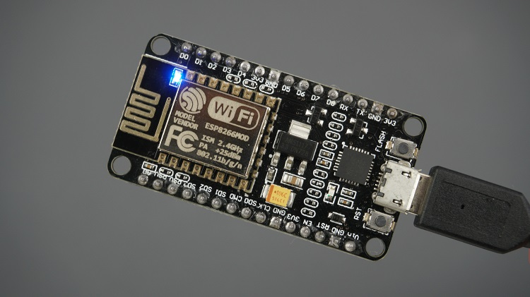

**Serial Monitor**

You can click on the Serial Monitor icon to open the Serial Monitor tab.

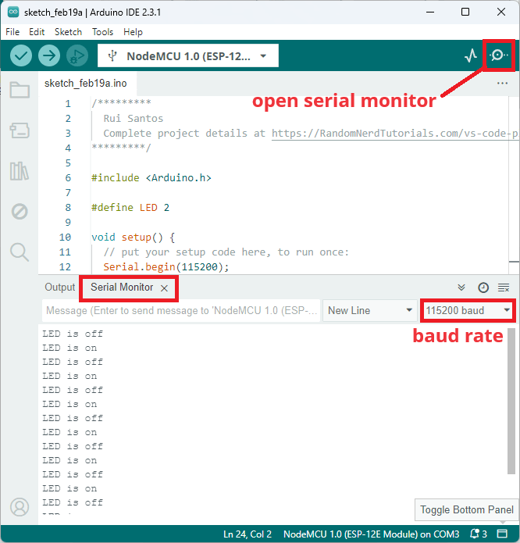

That’s it! You’ve installed the ESP8266 Boards successfully in Arduino IDE 2.

**Filesystem Uploader Plugin (LittleFS)**

If you want to add support to upload files to the ESP8266 LittleFS filesystem, you can follow the next tutorial:

* [Arduino IDE 2: Install ESP8266 NodeMCU LittleFS Uploader (Upload Files to the Filesystem)](https://randomnerdtutorials.com/arduino-ide-2-install-esp8266-littlefs/)

**Troubleshooting**

**1)** If you try to upload a new sketch to your ESP8266 and you get this error message “*esptool.FatalError: Failed to connect to ESP8266: Timed out waiting for packet header*“. It means that your ESP8266 is not in flashing/uploading mode.

Having the right board name and COM port selected, follow these steps:

* Hold-down the **BOOT/FLASH** button in your ESP8266 development board
* Press the **Upload** button in the Arduino IDE to upload your sketch
* When you see the  “*Connecting….*” message in your Arduino IDE, release the finger from the **BOOT/FLASH** button
* After that, you should see the “*Done uploading*” message

Your ESP8266 should have the new sketch running. Press the **ENABLE/RESET** button to restart the ESP8266 and run the new uploaded sketch.

**2)** If you get the error “COM Port not found/not available”, you might need to install the CP210x Drivers:

* [Install USB Drivers – CP210x USB to UART Bridge (Windows PC)](https://randomnerdtutorials.com/install-esp32-esp8266-usb-drivers-cp210x-windows/)
* [Install USB Drivers – CP210x USB to UART Bridge (Mac OS X)](https://randomnerdtutorials.com/install-esp32-esp8266-usb-drivers-cp210x-mac-os/)

**Wrapping Up**

This is a quick guide that shows how to prepare Arduino IDE 2 for the ESP8266 Boards on a Windows PC, Mac OS X, or Linux computer.

Next, you might want to read: [Getting started with ESP8266](https://randomnerdtutorials.com/getting-started-with-esp8266-wifi-transceiver-review/) or learn more about the ESP8266 board with our resources:

* [Build ESP8266 Web Servers with Arduino IDE (eBook)](https://randomnerdtutorials.com/build-web-servers-esp32-esp8266-ebook/)
* [Home Automation using ESP8266](https://randomnerdtutorials.com/home-automation-using-esp8266/)
* [More ESP8266 Projects and Tutorials…](https://randomnerdtutorials.com/projects-esp8266/)

](https://randomnerdtutorials.com/pcbway)

[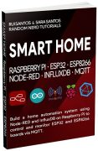](https://randomnerdtutorials.com/smart-home-ebook/)

[**SMART HOME with Raspberry Pi, ESP32, ESP8266 [eBook]**](https://randomnerdtutorials.com/smart-home-ebook/)

Learn how to build a home automation system and we’ll cover the following main subjects: Node-RED, Node-RED Dashboard, Raspberry Pi, ESP32, ESP8266, MQTT, and InfluxDB database [**DOWNLOAD »**](https://randomnerdtutorials.com/smart-home-ebook/)

**Recommended Resources**

[**Build a Home Automation System from Scratch »**](https://randomnerdtutorials.com/build-a-home-automation-system-for-100/)With Raspberry Pi, ESP8266, Arduino, and Node-RED.

[**Home Automation using ESP8266 eBook and video course »**](https://randomnerdtutorials.com/home-automation-using-esp8266/)Build IoT and home automation projects.

[**Arduino Step-by-Step Projects »**](https://randomnerdtutorials.com/arduino-step-by-step-projects/)Build 25 Arduino projects with our course, even with no prior experience!

**What to Read Next…**

[ESP8266 Remote Controlled Sockets](https://randomnerdtutorials.com/esp8266-remote-controlled-sockets/)

[Installing the ESP32 Board in Arduino IDE (Mac OS X and Linux instructions)](https://randomnerdtutorials.com/installing-the-esp32-board-in-arduino-ide-mac-and-linux-instructions/)

[[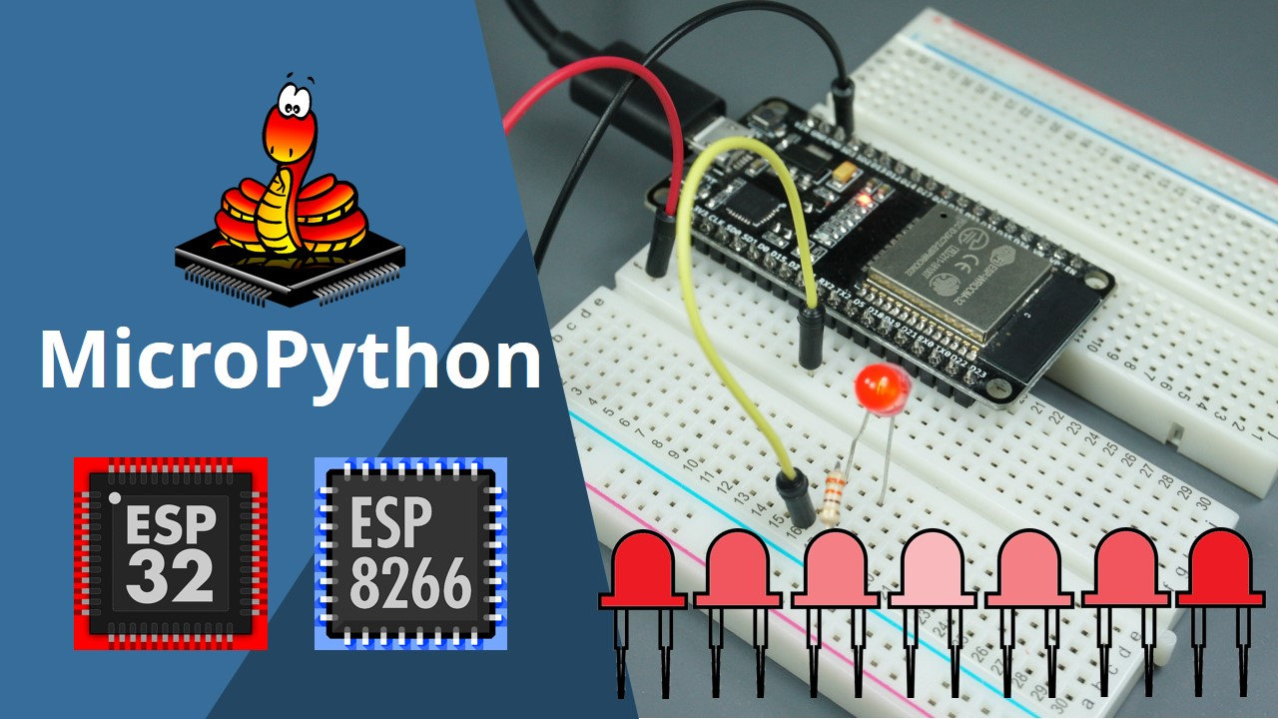](https://randomnerdtutorials.com/esp32-esp8266-pwm-micropython/)](https://randomnerdtutorials.com/esp32-esp8266-pwm-micropython/)

[ESP32/ESP8266 PWM with MicroPython – Dim LED](https://randomnerdtutorials.com/esp32-esp8266-pwm-micropython/)

**Enjoyed this project? Stay updated by subscribing our newsletter!**

Top of Form

SUBSCRIBE

Bottom of Form

**15 thoughts on “Installing ESP8266 NodeMCU Board in Arduino IDE 2 (Windows, Mac OS X, Linux)”**

1. A person with a white circle

   AI-generated content may be incorrect.

**Ed**

[May 22, 2021 at 8:03 am](https://randomnerdtutorials.com/installing-esp8266-nodemcu-arduino-ide-2-0/#comment-610301)

“Linux: extract the downloaded file, and open the arduino-ide file that will launch the IDE.”  
may sound simpler than it is. the only way that worked for me is from the command line by going to the proper directory and typing ./arduino-ide

[Reply](https://randomnerdtutorials.com/installing-esp8266-nodemcu-arduino-ide-2-0/#comment-610301)

1. A person with a white circle

   AI-generated content may be incorrect.

**Paul**

[June 4, 2021 at 12:51 am](https://randomnerdtutorials.com/installing-esp8266-nodemcu-arduino-ide-2-0/#comment-621451)

Linuxmint: Your instructions were too glib and left out much complexity. I am erasing the entire mess and sticking with 1.8.15 until you and Arduino get the bugs out.

[Reply](https://randomnerdtutorials.com/installing-esp8266-nodemcu-arduino-ide-2-0/#comment-621451)

1. A person with a white circle

   AI-generated content may be incorrect.

**jonatã**

[October 14, 2021 at 12:12 am](https://randomnerdtutorials.com/installing-esp8266-nodemcu-arduino-ide-2-0/#comment-683383)

excelent tutorial.  
I had a problem: my board doesnt update the code, I have already tried many differents boards( ESP8266, nodemcu, wemos mini R1 and I always have the same message. I did a test in Windows 10 and no problems.  
I am using Ubuntu 20.

Compilation complete.  
esptool.py v3.0  
Serial port /dev/ttyS0  
Connecting…….._____….._____….._____….._____….._____….._____….._____  
Traceback (most recent call last):  
File “/home/jonata/.arduino15/packages/esp8266/hardware/esp8266/3.0.2/tools/upload.py”, line 66, in  
esptool.main(cmdline)  
File “/home/jonata/.arduino15/packages/esp8266/hardware/esp8266/3.0.2/tools/esptool/esptool.py”, line 3552, in main  
esp.connect(args.before, args.connect_attempts)  
File “/home/jonata/.arduino15/packages/esp8266/hardware/esp8266/3.0.2/tools/esptool/esptool.py”, line 529, in connect  
raise FatalError(‘Failed to connect to %s: %s’ % (self.CHIP_NAME, last_error))  
esptool.FatalError: Failed to connect to ESP8266: Timed out waiting for packet header  
Upload error: Error: 13 INTERNAL: Failed uploading: uploading error: exit status 1

[Reply](https://randomnerdtutorials.com/installing-esp8266-nodemcu-arduino-ide-2-0/#comment-683383)

* + A person with a white circle

    AI-generated content may be incorrect.

**Walton**

[September 5, 2023 at 10:13 pm](https://randomnerdtutorials.com/installing-esp8266-nodemcu-arduino-ide-2-0/#comment-858739)

try going in to board manager and setting the esp8266 driver files from version 3.1.1 to 3.1.0  
this may help.

[Reply](https://randomnerdtutorials.com/installing-esp8266-nodemcu-arduino-ide-2-0/#comment-858739)

1. A person with a white circle

   AI-generated content may be incorrect.

**Ivan Goga**

[January 20, 2022 at 9:05 pm](https://randomnerdtutorials.com/installing-esp8266-nodemcu-arduino-ide-2-0/#comment-720259)

Hallo.  
I have a problem with my board and programming. Here is listing of my problem:

Compilation complete.  
esptool.py v3.0  
Serial port COM3  
Connecting…….._____….._____….._____….._____….._____….._____….._____  
Traceback (most recent call last):  
File “C:\Users\ivang\AppData\Local\Arduino15\packages\esp8266\hardware\esp8266\3.0.2/tools/upload.py”, line 66, in  
esptool.main(cmdline)  
File “C:/Users/ivang/AppData/Local/Arduino15/packages/esp8266/hardware/esp8266/3.0.2/tools/esptool\esptool.py”, line 3552, in main  
esp.connect(args.before, args.connect_attempts)  
File “C:/Users/ivang/AppData/Local/Arduino15/packages/esp8266/hardware/esp8266/3.0.2/tools/esptool\esptool.py”, line 529, in connect  
raise FatalError(‘Failed to connect to %s: %s’ % (self.CHIP_NAME, last_error))  
esptool.FatalError: Failed to connect to ESP8266: Timed out waiting for packet header  
Upload error: Failed uploading: uploading error: exit status 1

Thank you for answer.  
Ivan

[Reply](https://randomnerdtutorials.com/installing-esp8266-nodemcu-arduino-ide-2-0/#comment-720259)

* + A person with a white circle

    AI-generated content may be incorrect.

**Ivan Goga**

[January 21, 2022 at 8:40 am](https://randomnerdtutorials.com/installing-esp8266-nodemcu-arduino-ide-2-0/#comment-720334)

Hi, in the meantime I tried again and today I finally succeeded. I switched to a new computer, the old one was 32bit, the new one I now have 64-bit, I transfer these programs. I’m an amateur in these things. Well thank you

[Reply](https://randomnerdtutorials.com/installing-esp8266-nodemcu-arduino-ide-2-0/#comment-720334)

1. A person with a white circle

   AI-generated content may be incorrect.

**Ajay B**

[September 15, 2022 at 8:46 am](https://randomnerdtutorials.com/installing-esp8266-nodemcu-arduino-ide-2-0/#comment-783598)

Thanks for these random but always usefull articles 🙂

September 2022: I downloaded the new ‘stable’ release of the Arduino 2.0rc IDE on Mac Monterey 12.6 … and it’s still buggy!!! Would it open anything other than a default document? No. Would it compile? There seemed to be some missing dependency to XCode which was already installed on Monterey???

Even though the Arduino IDE is now what it should have been eight years ago, I will be staying with VS Code and the PlatformIO extension – which together do embedded IoT development in one slick IDE.

Sorry Arduino 🙁

[Reply](https://randomnerdtutorials.com/installing-esp8266-nodemcu-arduino-ide-2-0/#comment-783598)

* + A person with long brown hair

    AI-generated content may be incorrect.

**Sara Santos**

[September 15, 2022 at 10:05 am](https://randomnerdtutorials.com/installing-esp8266-nodemcu-arduino-ide-2-0/#comment-783623)

Hi.  
At the moment, I still prefer using Arduino 1.8 or VS Code + PlatformIO instead of Arduino 2.0.  
Regards,  
Sara

[Reply](https://randomnerdtutorials.com/installing-esp8266-nodemcu-arduino-ide-2-0/#comment-783623)

* + - A person with a white circle

      AI-generated content may be incorrect.

[**Graham**](http://[none]/)

[September 19, 2022 at 1:19 pm](https://randomnerdtutorials.com/installing-esp8266-nodemcu-arduino-ide-2-0/#comment-784502)

I agree Sara, Arduino 1.8 is more friendly to use. Something is not quite right with the user experience on v.2.0.

Please keep up the great work (both of you).

[Reply](https://randomnerdtutorials.com/installing-esp8266-nodemcu-arduino-ide-2-0/#comment-784502)

* + - * A person with long brown hair

        AI-generated content may be incorrect.

**Sara Santos**

[September 19, 2022 at 10:23 pm](https://randomnerdtutorials.com/installing-esp8266-nodemcu-arduino-ide-2-0/#comment-784599)

Thanks 🙂

[Reply](https://randomnerdtutorials.com/installing-esp8266-nodemcu-arduino-ide-2-0/#comment-784599)

1. A person with a white circle

   AI-generated content may be incorrect.

**Mostafa**

[September 5, 2023 at 4:50 pm](https://randomnerdtutorials.com/installing-esp8266-nodemcu-arduino-ide-2-0/#comment-858707)

Hi, Can it be connected to a network (wifi or data mobile) other than the one to which the module is connected?

[Reply](https://randomnerdtutorials.com/installing-esp8266-nodemcu-arduino-ide-2-0/#comment-858707)

1. A person with a white circle

   AI-generated content may be incorrect.

**Dusan**

[March 10, 2024 at 10:58 pm](https://randomnerdtutorials.com/installing-esp8266-nodemcu-arduino-ide-2-0/#comment-897603)

Greetings to Sara and Rui.  
I installed Arduino IDE 2.3.2.,it worked fine. Then I needed to replace the board, it did not find a new one, in the end no ESP could be installed anymore. Reinstalling the complete IDE did not help either. So where is wrong, I expect an answer from the Arduino team on their site as well.  
Why can’t boards from Esspressif ESP8266 or ESP 32 be installed in the Arduino IDE 2.x.x. Support is already declared, or even real. Whoever harms, the Russians, you harm everyone, or the Chinese, Espressif has its IDE, or the Italians, pushing its paid cloud.

[Reply](https://randomnerdtutorials.com/installing-esp8266-nodemcu-arduino-ide-2-0/#comment-897603)

* + A person with long brown hair

    AI-generated content may be incorrect.

**Sara Santos**

[March 11, 2024 at 11:07 am](https://randomnerdtutorials.com/installing-esp8266-nodemcu-arduino-ide-2-0/#comment-897689)

Hi.  
I’m sorry, but I didn’t understand your issue???  
You can install ESP8266 and ESP32 boards on the new Arduino IDE without any problem.  
Please provide more details about your issue.  
Regards,  
Sara

[Reply](https://randomnerdtutorials.com/installing-esp8266-nodemcu-arduino-ide-2-0/#comment-897689)

1. A person with a white circle

   AI-generated content may be incorrect.

**Dusan**

[March 11, 2024 at 3:33 pm](https://randomnerdtutorials.com/installing-esp8266-nodemcu-arduino-ide-2-0/#comment-897744)

Greetings to Sara and Rui.  
No board from Espressif can be installed, neither 32 nor 8266, nor from Arduino, nor from Espressif. But I have ESP 8266 boards functional, I will not discard them. Rather, bye, bye Arduino IDE.

[Reply](https://randomnerdtutorials.com/installing-esp8266-nodemcu-arduino-ide-2-0/#comment-897744)

* + A person with long brown hair

    AI-generated content may be incorrect.

**Sara Santos**

[March 11, 2024 at 5:18 pm](https://randomnerdtutorials.com/installing-esp8266-nodemcu-arduino-ide-2-0/#comment-897769)

That’s weird…  
Maybe you’re doing something wrong?  
It works perfectly fine on my computer…  
Regards,  
Sara

[Reply](https://randomnerdtutorials.com/installing-esp8266-nodemcu-arduino-ide-2-0/#comment-897769)

**Leave a Comment**

Top of Form

Comment

NameEmailWebsite

 Notify me of follow-up comments by email.

 Notify me of new posts by email.

Bottom of Form

**Affiliate Disclosure:** *Random Nerd Tutorials is a participant in affiliate advertising programs designed to provide a means for us to earn fees by linking to Amazon, eBay, AliExpress, and other sites. We might be compensated for referring traffic and business to these companies.*

](https://randomnerdtutorials.com/learn-esp32-with-arduino-ide/)  
[**Learn ESP32 with Arduino IDE eBook »**](https://randomnerdtutorials.com/learn-esp32-with-arduino-ide/) Complete guide to program the ESP32 with Arduino IDE!

[**SMART HOME with Raspberry Pi, ESP32, and ESP8266 »**](https://randomnerdtutorials.com/smart-home-ebook/) learn how to build a complete home automation system.

[**Learn Raspberry Pi Pico/Pico W with MicroPython​ »**](https://randomnerdtutorials.com/raspberry-pi-pico-w-micropython-ebook/) The complete getting started guide to get the most out of the the Raspberry Pi Pico/Pico W (RP2040) microcontroller board using MicroPython programming language.

[**🔥 Learn LVGL: Build GUIs for ESP32 Projects​ »**](https://randomnerdtutorials.com/learn-lvgl-esp32-ebook/) Learn how to build Graphical User Interfaces (GUIs) for ESP32 Projects using LVGL (Light Versatile Graphics Library) with the Arduino IDE.

* [About](https://randomnerdtutorials.com/about/)
* [Support](https://randomnerdtutorials.com/support)
* [Terms and Conditions](https://randomnerdtutorials.com/terms)
* [Privacy Policy](https://randomnerdtutorials.com/privacy-policy/)
* [Refunds](https://randomnerdtutorials.com/returns-and-refunds/)
* [Complaints’ Book](https://www.livroreclamacoes.pt/inicio/)
* [MakerAdvisor.com](https://makeradvisor.com/)
* [Join the Lab](https://rntlab.com/)

Copyright © 2013-2025 · RandomNerdTutorials.com · All Rights Reserved